Mongodb lab:

Vagrant: helps transfer files from pc to virtual machine

Virtual machine: Uses our pc memory, OS, space

<https://www.virtualbox.org/wiki/Downloads>

<https://www.vagrantup.com/downloads.html>

vagrant up

vagrant status

<https://sourceforge.net/projects/mingw/files/>

Reference: <https://university.mongodb.com/mercury/M103/2019_June/chapter/Chapter_0_Introduction_Setup/lesson/5a9b89e997182d4140a45ecb/lecture>

**Lecture Instructions**

Throughout this course we'll be using Vagrant as our environment for homework exercises.

Vagrant enables us to have a consistent deployment environment for all students. This makes validating the correctness of a homework solution a lot easier. It will also aid you when asking and answering questions on the discussion forum as you know all of your peers have a near identical environment.

Vagrant requires an hypervisor or virtual environment provider to operate. For this purpose we use [VirtualBox](https://www.virtualbox.org/).

Below you'll find instructions on how to install [Vagrant](https://www.vagrantup.com/) and [VirtualBox](https://www.virtualbox.org/) on Windows, OSX and Linux.

**General Notes**

* The installation of the Vagrant environment takes, in a fast network (49Mbps download, 194Mbps upload), around 2:33 minutes to complete. Account for a considerably longer time on slower networks!
* The video instructions might not reflect the exact commands required for your workstation operating system.
* The [Vagrant](https://www.vagrantup.com/) environment files are made available as a downloadable zip file.

**Installing Vagrant on OSX or Linux**

1. Install VirtualBox

Download and installation should be straightforward. Go to the [VirtualBox downloads page](https://www.virtualbox.org/wiki/Downloads), download the setup binary for your appropriate OS, and run the installer.

If you run into issues installing VirtualBox on a recent version of MacOS, you may want to look at this [knowledge article](https://apple.stackexchange.com/questions/300510/virtualbox-5-1-8-installation-didnt-install-kernel-extensions-how-do-i-fix-thi).

1. Install Vagrant

After VirtualBox has been installed you can go ahead and [download](https://www.vagrantup.com/downloads.html) and [install](https://www.vagrantup.com/docs/installation/) Vagrant.

**Installing Vagrant on Windows**

1. Install VirtualBox

Download and installation should be pretty straightforward. Go to the [VirtualBox downloads page](https://www.virtualbox.org/wiki/Downloads), download the setup binary for Windows hosts, and run the installer.

**NOTE** If you are running Windows 7 Service pack 1, install [Vagrant 1.9.6](https://releases.hashicorp.com/vagrant/1.9.6/vagrant_1.9.6_x86_64.msi)

1. Install MinGW

Vagrant requires two important command-line tools: rsync and ssh. These command-line tools allow us to connect to our virtual machine and to sync files between our host and virtual machines. MinGW is a set of GNU utilities for software development on Windows. We'll use MinGW to install both rysncand ssh onto our Windows machine.

You should download and run the [MinGW Installer (mingw-get-setup.exe)](https://sourceforge.net/projects/mingw/files/).

1. Install rsync and ssh

The last step of the installation of MinGW is to specify the packages you want to install. From here you can mark rsync and ssh for installation like so:

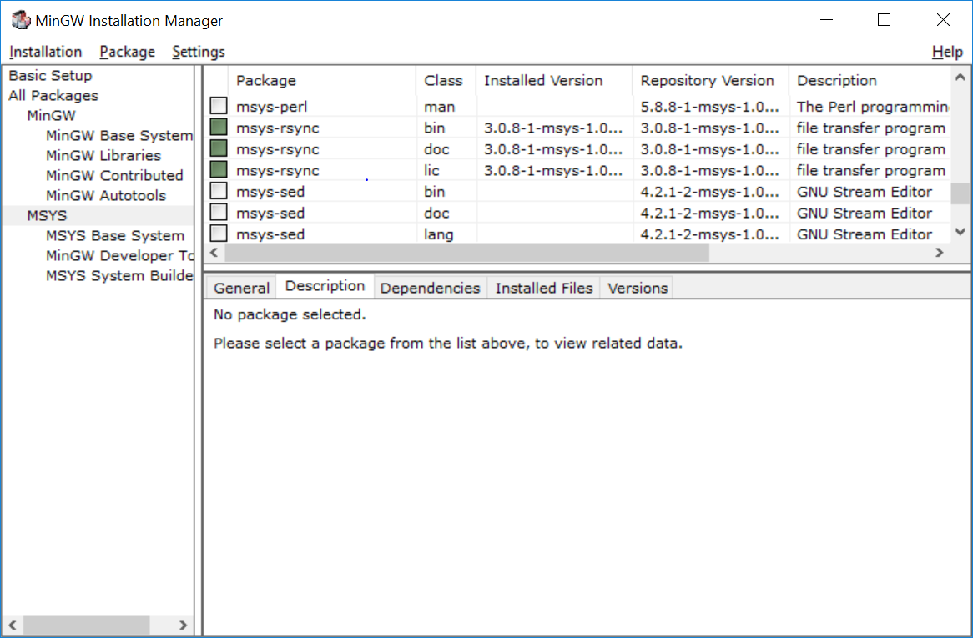 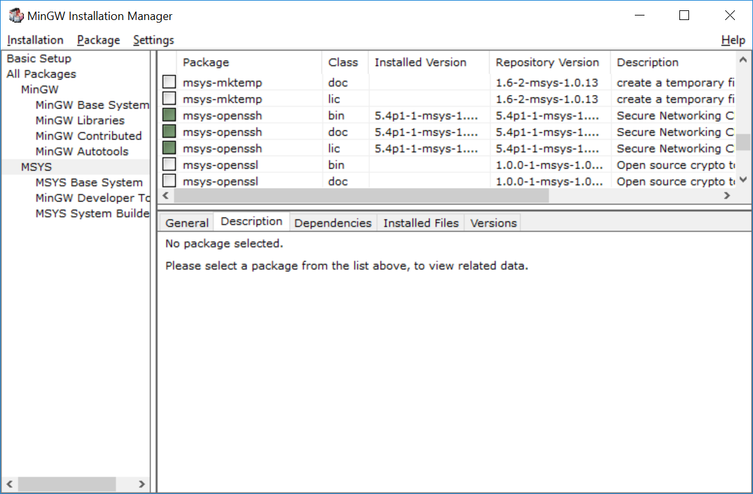

After marking the packages for installation you can go ahead and apply the changes:

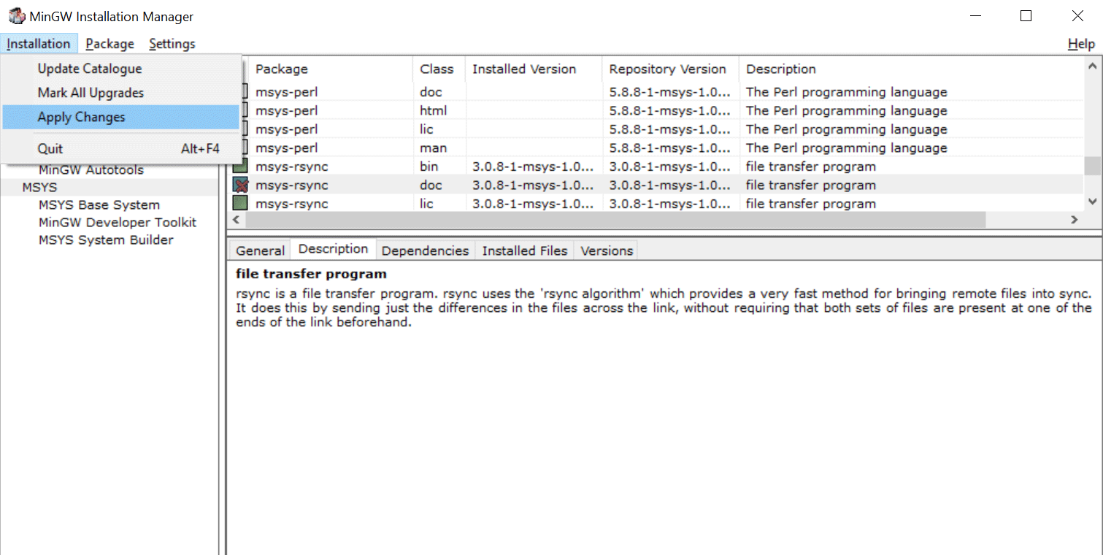

Assuming you've kept the default installation path rsync and ssh should be installed to the C:\MinGW\msys\1.0\bin directory. In order for these tools to be accessible via the command-line (and Vagrant) you'll need to add this directory to your PATH environment variable.

First go to Advanced system settings under System Properties and click "Environment Variables...":

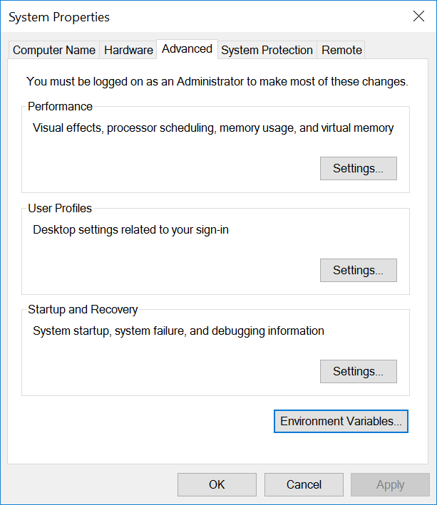

From there select the "Path" variable and click "Edit...".

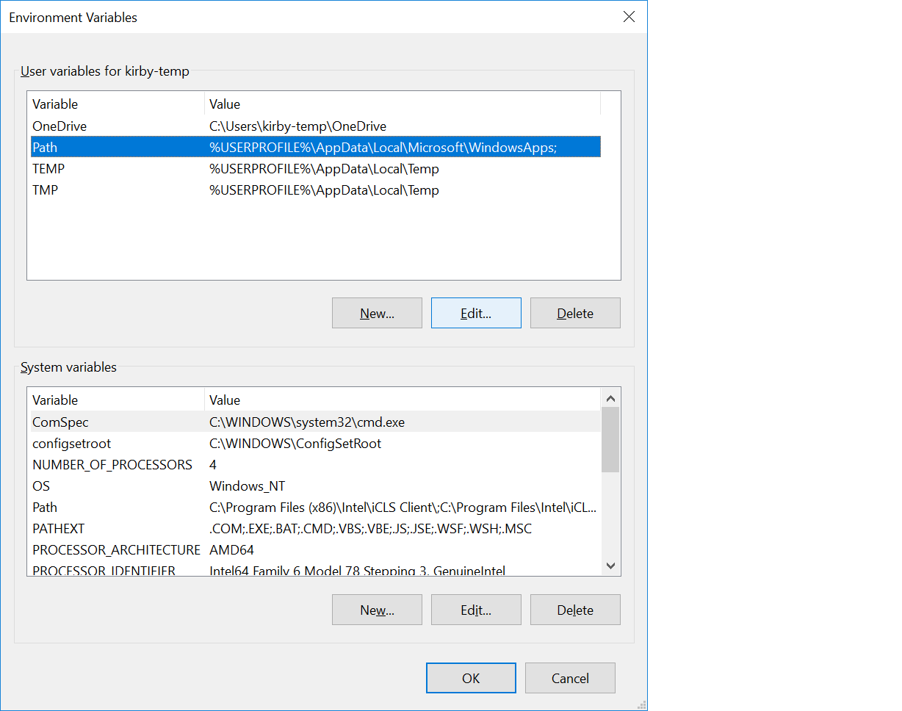

Directories in the PATH environment variable are deliminated by semicolons. You can now append the C:\MinGW\msys\1.0\bin directory to the end of the "Variable value."

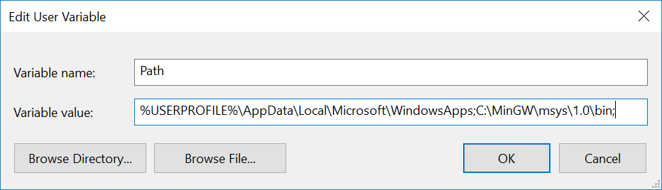

You can confirm that rsync and ssh are both successfully installed and accessible via your PATH by launching the command prompt (cmd) and running rsync and ssh respectively. Both commands should output usage information. If you receive an error about not being recognized as an internal or external command then you'll need revisit the steps above.

1. Install Vagrant

After all of the above prerequisites have been installed you can go ahead and [download](https://www.vagrantup.com/downloads.html) and [install](https://www.vagrantup.com/docs/installation/)Vagrant. This will require a restart of your machine.

After downloading the Handouts (provided in the next Lab), extract the zip folder in your current working directory.

From the directory m103/m103-vagrant-env, we can bring up the Vagrant environment:

m103-vagrant-env$ vagrant up

COPY

After bringing up the environment, we can provision Vagrant (to download datasets, validation scripts, etc.):

m103-vagrant-env$ vagrant provision

COPY

Once the environment is provisioned, we can connect with ssh:

m103-vagrant-env$ vagrant ssh

COPY

As you complete labs in this course, you will be asked to run validation scripts that check your work. These validators are stored inside the VM. You can run these validators from anywhere within the Vagrant environment. Do not run these validators from within a Mongo shell.

If you need to re-download these scripts, run the following command (from Vagrant):

vagrant@m103:~$ download_validators

**Problem:**

In order to effectively learn from this class, you should be completing problems in a real MongoDB cluster. To do this, we will use a development environment called Vagrant that makes it easy to provision a virtual machine with Virtualbox.

We first need to download [Vagrant](https://www.vagrantup.com/downloads.html) and [Virtualbox](https://www.virtualbox.org/wiki/Download_Old_Builds_5_1). Vagrant requires that we use version 5.1 of Virtualbox (in the link), so click the link and download the correct option for your operating system.

Now, download the handout above and create a folder in your home directory called m103. Copy the handout to this directory and then navigate to the handout directory m103-vagrant-env in your terminal. Bring up your Vagrant environment by running these commands (this will take a few minutes):

vagrant up --provision

COPY

This command brings up your virtual machine, if it's not already running. It also builds directories in the VM and downloads all the software and validation scripts necessary to complete this course.

vagrant ssh

COPY

This command connects to your Vagrant instance using SSH. If it prompts you for a username/password, use the username **vagrant** and the password **vagrant**.

To validate that your box is running properly, execute the following command from the Vagrant command line:

vagrant@m103:~$ validate_box

### roubleshooting the Vagrant Environment

In this lesson you can find the common pitfalls for setting up your vagrant environment as well as the troubleshooting guide .

**IP mismatch while doing ssh**

mXXX-vagrant-env$ vagrant ssh

Welcome to Ubuntu 14.04.5 LTS (GNU/Linux 3.13.0-153-generic x86_64)

<–some text–>

Swap usage: 0% IP address for eth1: 192.168.X.X

<–some more text–>

vagrant@mXXX:~$

COPY

If you are not able to view IP address for eth1 as shown above, then you can check the IP using:

vagrant@mXXX:~ ping m103

COPY

If the IP address for eth1(192.168.X.X) or the IP address in the output of above ping command differs for some reason, then destroy your vagrant using:

vagrant@mXXX:~ exit

mXXX-vagrant-env$ vagrant destroy

COPY

Then re-provision your vagrant VM by running vagrant up again. If it still doesn't work, then please share the following:

* what was the value in the VM
* what is the value for the host
* output of vagrant global status

**Localhost IP mismatch while configuring replica sets:**

If you encounter below error:

Failed to connect to 127.0.1.1:27001, in(checking socket for error after poll), reason: Connection refused

COPY

Check the localhost IP address using:

vagrant@mXXX:~ ping localhost

COPY

If the IP address is set to 127.0.1.1, instead of expected 127.0.0.1, then run the following command to resolve this issue:

vagrant@mXXX:~ exit

mXXX-vagrant-env$ vagrant halt

mXXX-vagrant-env$ vagrant up --provision

COPY

**Password for vagrant?**

If you are being asked for the password, then credentials are:

username: vagrant

password: vagrant

COPY

*Need to Enter Password Again and Again for Vagrant ??*

Solution:

If you are working with PuTTy and every time you enter vagrant, it asks for your password, please try the following solution:

1. Open the **PuTTYgen** utility;
2. Click on the Load button;
3. Open the private_key file under the VM directory structure
4. Change the value in the Number of bits in a generated key: field to 2048 , leave everything else as it is
5. Save the file as private.ppk
6. Use this private.ppk file as the "private key file for authentication" in PuTTy session config

All works fine Source: <https://github.com/Varying-Vagrant-Vagrants/VVV/wiki/Connect-to-Your-Vagrant-Virtual-Machine-with-PuTTY>

**Vagrant Issues on windows:**

*Must redirect to new repository for old Vagrant versions*

If you encounter this error when provisioning vagrant:

G:\mXXX>vagrant up --provision

COPY

Must redirect to new repository for old Vagrant versions It just hangs there for a long time.

Here are some steps that were followed by some students that worked:

For Windows7 SP1 machine :

1. Download the latest versions of vagrant and virtual box.
2. Update Powershell from 2 to 3 using the instructions here: <https://docs.microsoft.com/en-us/skypeforbusiness/set-up-your-computer-for-windows-powershell/download-and-install-windows-powershell-3-0>
3. Enable the virtualization in the BIOS (on some machines, it was under device configuration), Steps to do it can be found out here: Enable-Hardware- (<https://www.wikihow.tech/Enable-Hardware-Virtualization>)

Launch vagrant --repair or the command mentioned in error message, and again ran vagrant up , then try again.

**Stderr: VBoxManage.exe: error: VT-x is not available**

If you encounter below error:

Command: ["startvm", "d3da0d72-3297-4e35-b301-23c8cfb4db96", ""–type",

"headless "]

Stderr: VBoxManage.exe: error: VT-x is not available (VERR_VMX_NO_VMX)

VBoxManage.exe: error: Details: code E_FAIL (0x80004005), component

ConsoleWrap, interface IConsole

COPY

Here is the possible solution:

1. Enable virtualization in the BIOS.
2. Make sure you have Hyper-V turned off in Windows 10 For Windows 10: Press Windows key. Type "Turn Windows features on or off" Deselect the checkbox next to Hyper-V. Select OK. Select Restart now.

**Vagrant issues on Ubuntu:**

VBoxManage: error: Failed to create the host-only adapter

Error:

==> mongod-mXXX: Clearing any previously set network interfaces…

There was an error while executing VBoxManage, a CLI used by Vagrant

for controlling VirtualBox. The command and stderr is shown below.

Command: ["hostonlyif", "create"]

Stderr: 0%…

Progress state: NS_ERROR_FAILURE

VBoxManage: error: Failed to create the host-only adapter

VBoxManage: error: VBoxNetAdpCtl: Error while adding new interface: failed to open /dev/vboxnetctl: No such file or directory

VBoxManage: error: Details: code NS_ERROR_FAILURE (0x80004005), component HostNetworkInterfaceWrap, interface IHostNetworkInterface

VBoxManage: error: Context: "RTEXITCODE handleCreate(HandlerArg*)" at line 94 of file VBoxManageHostonly.cpp

1355238bc7db15948d1084776f2d62c9d060a2dd.png

COPY

Possible Solution:

Disable the Secure Boot on your Ubuntu machine.

Steps to disable Secure boot:

* Click simultaneously the shortcut Restart + Shift key.
* Click Troubleshoot → Advanced options → Start-up Settings → Restart.
* Click repeatedly the F10 key (BIOS setup), before the "Startup Menu" opens.
* Go to Boot Manager and disable the option Secure Boot. ...
* Save the changes and reboot.

**SSL error**

Error: SSL certificate problem: self signed certificate in certificate chain

Bringing machine 'mongod-mXXX' up with 'virtualbox' provider…

==> mongod-mXXX: Box 'ubuntu/trusty64' could not be found. Attempting to find and install…

mongod-mXXX: Box Provider: virtualbox

mongod-mXXX: Box Version: >= 0

The box 'ubuntu/trusty64' could not be found or

could not be accessed in the remote catalog. If this is a private

box on HashiCorp's Vagrant Cloud, please verify you're logged in via

vagrant login. Also, please double-check the name. The expanded

URL and error message are shown below:

URL: ["https://vagrantcloud.com/ubuntu/trusty64 1"]

Error: SSL certificate problem: self signed certificate in certificate chain.

COPY

This is most likely a consequence of your anti-virus blocking the execution of vagrant or its access the system certificates.

Possible Solution:

*Disable Antivirus and restart you vagrant machine*

**Restarting/Destroying Vagrant from Virtual Box GUI**

*Problem: If you are unsure on how to destroy or restart or shutdown vagrant.*

Solution:

* Open VirtualBox
* From Left side, right-click on vagrant environment
* You can see options like : "Start", "Remove" etc
* You can also modify memory allocation for vagrant environment here.

[Proceed to next section](https://university.mongodb.com/mercury/M103/2019_June/chapter/Chapter_1_The_Mongod/lesson/5a96e969dce509e56145f6a3/lecture)